Suresh Ravuri

CMPE 256: Assignment 05

**Open CV and Deep Learning**

Please note that you can also view the google Collab notebook at my GitHub Repository link:

<https://github.com/sureshravuris/Image-Data-Mining--LBP-OpenCV-DeepLearning/tree/master/ImageDataMining-OpenCVAndDeepLearning>

Please see below for the output that was generated by running my Google Collab notebook on the pictures that the professor provided to us.

Deep Learning Pictures:

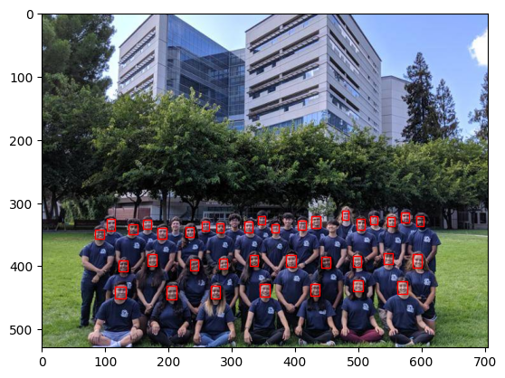

Open CV Pictures:

